
Specialist Medical Review Council

Declarations

Section 196W
Veterans’ Entitlements Act 1986

Re: Statements of Principles Nos. 13 & 14 of 2009
In Respect of Macular Degeneration
Matter No. 2009/16
Request for Review Declaration No. 16

1. In relation to the Repatriation Medical Authority (the RMA) Statement of Principles No. 13 of 2009 in respect of macular degeneration and death from macular degeneration, made under subsection 196B (2) of the Veterans' Entitlements Act 1986 (the VEA), the Specialist Medical Review Council (the Council) under subsection 196W of the VEA:
DECLARES THAT it is of the view that there is sound medical-scientific evidence on which the RMA could have relied to amend the Statement of Principles to include the factors set out below; and
DIRECTS the RMA to amend Statement of Principles No. 13 of 2009 by including the following factor in respect of passive smoking:
    - For late macular degeneration only:
being in an atmosphere with a visible tobacco smoke haze in an enclosed space for at least 10 000 hours within the 20 years before the clinical onset of late macular degeneration, and where the person was a non-smoker during the entire period of the exposure.
2. In relation to the RMA Statement of Principles No. 14 of 2009 in respect of macular degeneration and death from macular degeneration, made under subsection 196B (3) of the VEA, the Council under subsection 196W of the VEA:
DECLARES THAT it is of the view that the sound medical-scientific evidence available to the RMA is insufficient to justify an amendment to include a factor for exposure to passive smoking or any other factor.

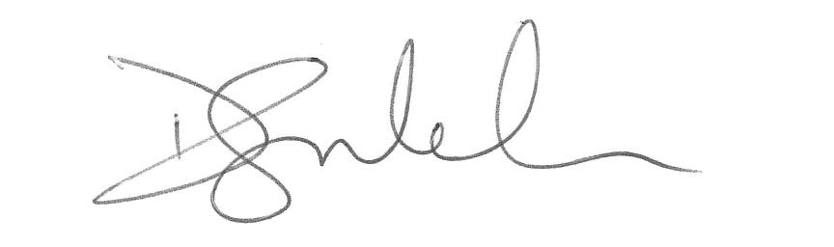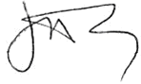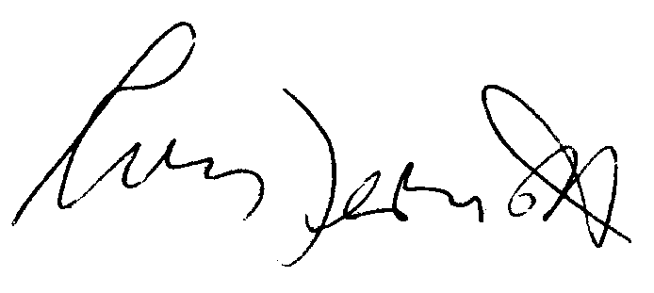

David Glen  Newman  Presiding Councillor | Ronald Paul Mitchell  Councillor | Justin O’Day  Councillor | Robyn McDermott  Councillor

The Common Seal of the )
Specialist Medical Review )
Council was affixed by )
authority of the Council in )
the presence of: )

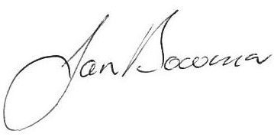
Jan Bowman
Registrar, SMRC

Dated this twenty seventh day of March 2012

